**Inference Procedures - Question 1 (6 marks)**

A test of a specific blood factor has been devised so that, for adults in the UK and Ireland, the test score is normally distributed with mean 100 and standard deviation 10.

A clinical research organization needs to test whether the mean score of sufferers from a particular disease differs from the mean score of the general population on this test.

A study has obtained the following test scores for 14 randomly selected patients suffering from the disease.

***104 112 110 107 101 103 101 102 103 102 101 120 112 103***

(see DAT81)

1. Compute a 99% confidence interval for the mean of patient’s blood factor scores.[2 Marks]
2. We wish to determine whether or not the mean score for patients is significantly different from the general population. Using the confidence interval, perform a hypothesis test. State your null and alternative hypothesis clearly. [3 Marks]
3. Perform a hypothesis test for this procedure, using a significance level of 5%. What is the p-value? [1 Mark]

**Testing Normality - Question 2 (6 Marks)**

The following graphical procedure was carried out to determine whether or not the data set from the previous question is normally distributed. 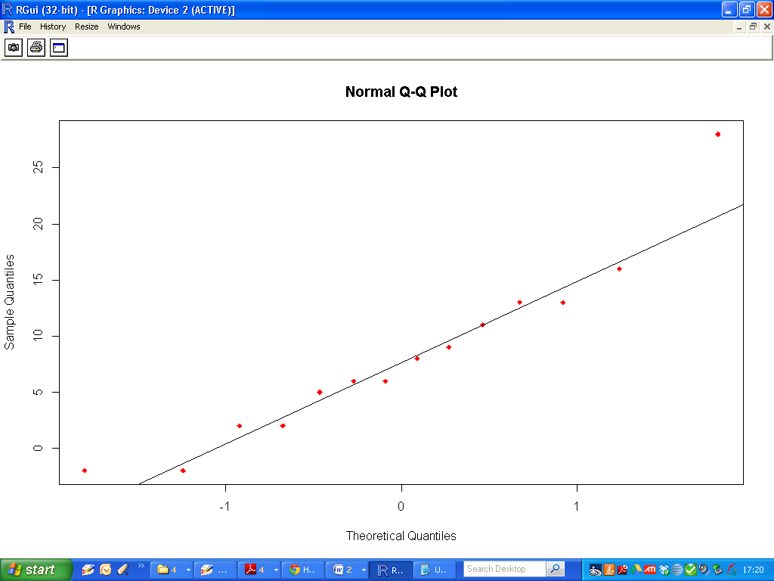1) Explain how this graphical procedure is used to make a determination. [2 Marks]

2) What is your conclusion for the data set from the study described in Question 1. [1 Mark]

3) Perform a formal hypothesis test for testing the normality of this data set (See DAT81). State your null and alternative hypothesis.[1 Mark]

4) What is your conclusion for this procedure? Justify your answer with reference to the p-value.[2 Marks]

**Linear Models - Question 3 (8 Marks)**

Consider the datasets X and Y

|  |  |  |
| --- | --- | --- |
|  | Variable | Data Set |
| 1 | X | DAT86 |
| 2 | Y | DAT87 |

Fit a linear model to the data, where ***X*** is the independent variable and ***Y***  is the dependent variable

1. Compute an estimate for the correlation coefficient of X and Y. [1 Mark]
2. What is the 95% confidence interval for this correlation coefficient estimate [2 Marks]
3. Write down the regression equation for this fitted model. [1 Mark]
4. What are the p-values associated with each of the regression coefficients? [1 Mark]
5. For the slope estimate, interpret the corresponding p-value.[ 1 Mark]
6. Compute the Akaike Information Criterion (AIC) for this fitted Model [1 Mark]